Time Management

Have created a day to day plan of the week – highlighting meetings (with their importance) and completion status as well as activities that need to be completed at what time.

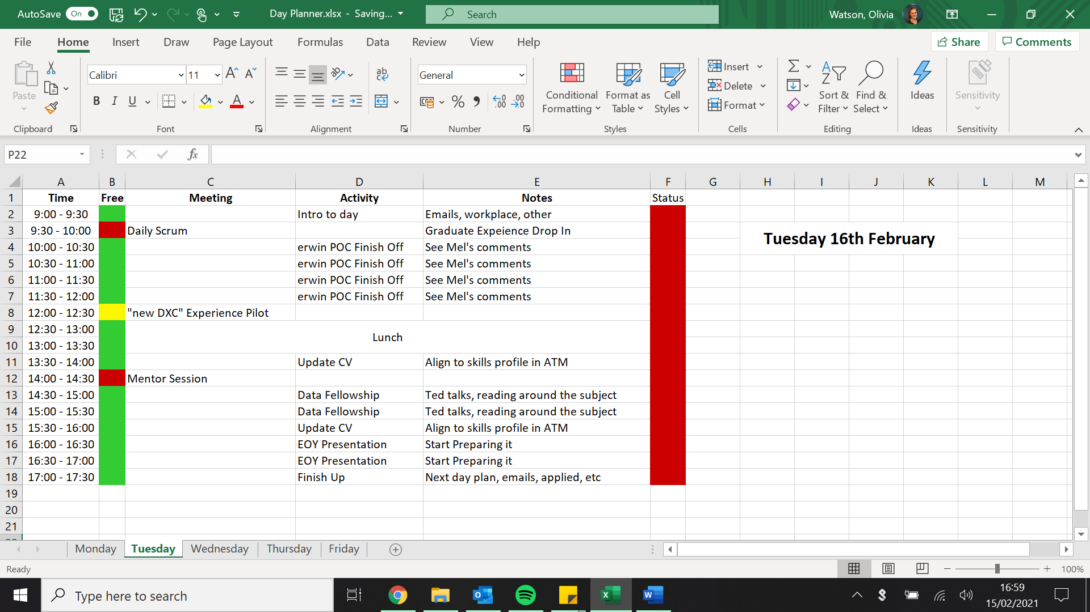

Also have a separate to-do list with due dates on to help fill out the day planner.

What went well:

* Productive use of time - allows me to maintain productivity throughout the day and not be trying to find what the next task I need to complete is.
* Have a comprehensive list of tasks that need to be completed which is better than previous
* Allows me to find time in the working day to fit in OTJ training

Even Better If:

* Need to account for additional meetings being added last minute to diary or additional work being needed
* Also account for things that overrun – try not to set myself too many tasks in a day – be more realistic
* Think about moving it to my teams’ calendar and blocking times where I need to focus so unexpected calls shouldn’t happen.